We imported the following:

1. The code of estimate correspondence is as follows:

Where I transformed the X points and used the argmin_min function to generate a list of shortest distance points from list 1 to list 2.

From there I checked if that distance is shorter than d_max and append if true.

1. The code of computing optimal rigid registration is as follows (next page):

In the code, I followed the pseudo code to calculate centroid, and covariance, constructed the optimal rotation, and recovered the optimal translation.

1. The ICP algorithm is as follows:

It takes in input and uses the above two algorithms to perform fixed number of times as requested.

1. RMSE:

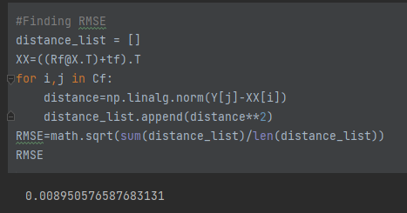

T & R

And the output is

With the code used to plot:

It’s seen that it’s a beautiful dragon.